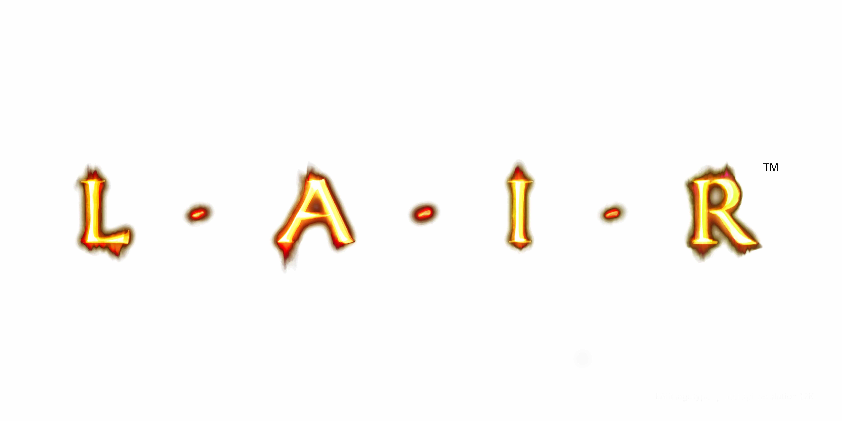


Gaming to the power of 5
Biography of Factor 5, developers of LairTM for PLAYSTATION®3

“The PS3™ certainly presented its share of challenges simply by being the most powerful game platform ever created.”
Julian Eggebrecht, President, Factor 5

Factor 5, a privately held company, was founded in Cologne, Germany in 1987 by five games enthusiasts. They have earned a reputation in the games industry as front-runners in producing games that stand out for their technical excellence and playability. Their most recent project has been a partnership with Sony Computer Entertainment to develop Lair™, the ground-breaking action-adventure aerial and ground combat title for PLAYSTATION®3 (PS3™).

Factor 5’s first success was KatakisTM in 1988, a title based on R-TypeTM which earned them the conversion rights to R-Type for the Amiga. Their real breakthrough title, however, was 1990's Turrican®: an instant hit that became a franchise on virtually every gaming platform of the day. 1994’s Indiana JonesTM - Greatest Adventures kicked off a decade-long collaboration with LucasArts Entertainment, culminating in the hugely successful and critically-acclaimed Star Wars®: Rogue SquadronTM series which saw the Factor 5 team pack their bags and move to San Rafael, California.
In 2005, Factor 5 announced they would move their focus away from franchise games and start developing original IP. The studio announced a partnership with Sony Computer Entertainment on the next generation title LairTM for PS3TM. This big-budget action, flight and combat title is set in a fantasy world of clashing civilizations replete with fire-breathing dragons, vast armies, Hollywood-standard animation and fully motion-sensitive gameplay employing the SIXAXIS® Wireless Controller. Described by Factor 5 President and Creative Director Julian Eggebrecht as “visceral, beautiful action”, LairTM arrives on shelves in Q4 and is expected to set a new benchmark in next generation gaming.
Julian Eggebrecht commented: “There was a certain amount of power needed for a game like Lair™ and motion control has been on our mind for many years, so the PS3™ was the perfect platform. We showed the concept to Sony, they loved it, and off we went. It’s a collaborative process in which developer and publisher truly share and believe in the same vision.”

Lairps3game.com

ENDS
For further information, please contact your local PR manager.

About Sony Computer Entertainment Europe Ltd.
Sony Computer Entertainment Europe (SCEE), based in London, is responsible for the distribution, marketing and sales of PLAYSTATION®3, PlayStation®2 and PSP™ (PlayStation®Portable) software and hardware in 102 territories across Europe, the Middle East, Africa and Oceania. SCEE also develops, publishes, markets and distributes entertainment software for these formats, and manages the third party licensing programs for the formats in these territories. Between its European debut on 24th November 2000 and the end of March 2007, over 44 million PlayStation®2 consoles have been shipped across the SCEE territories, over 117 million worldwide, making it one of the most successful consumer electronic products in history. Between its European debut on 1st September 2005 and the end of March 2007, over 8 million PSP® systems have been shipped across the SCEE territories, with over 25 million shipped worldwide since its Japanese launch in December 2004. Between its European debut on 23rd March 2007 and the end of March 2007, over 1.5 million PS3™ systems have been shipped across the SCEE territories, with over 5.5 million shipped worldwide since its Japanese launch in November 2006

More information about PlayStation products can be found at
www.playstation.com and www.yourpsp.com or visit the Virtual Press Office at www.scee.presscentre.com

PlayStation, PSP and the PlayStation logo are registered trademarks of Sony Computer Entertainment Inc. UMD (Universal Media Disc) is a trademark of Sony Computer Entertainment Inc. All other trademarks are property of their respective owners.

